CURRICULUM VITAE

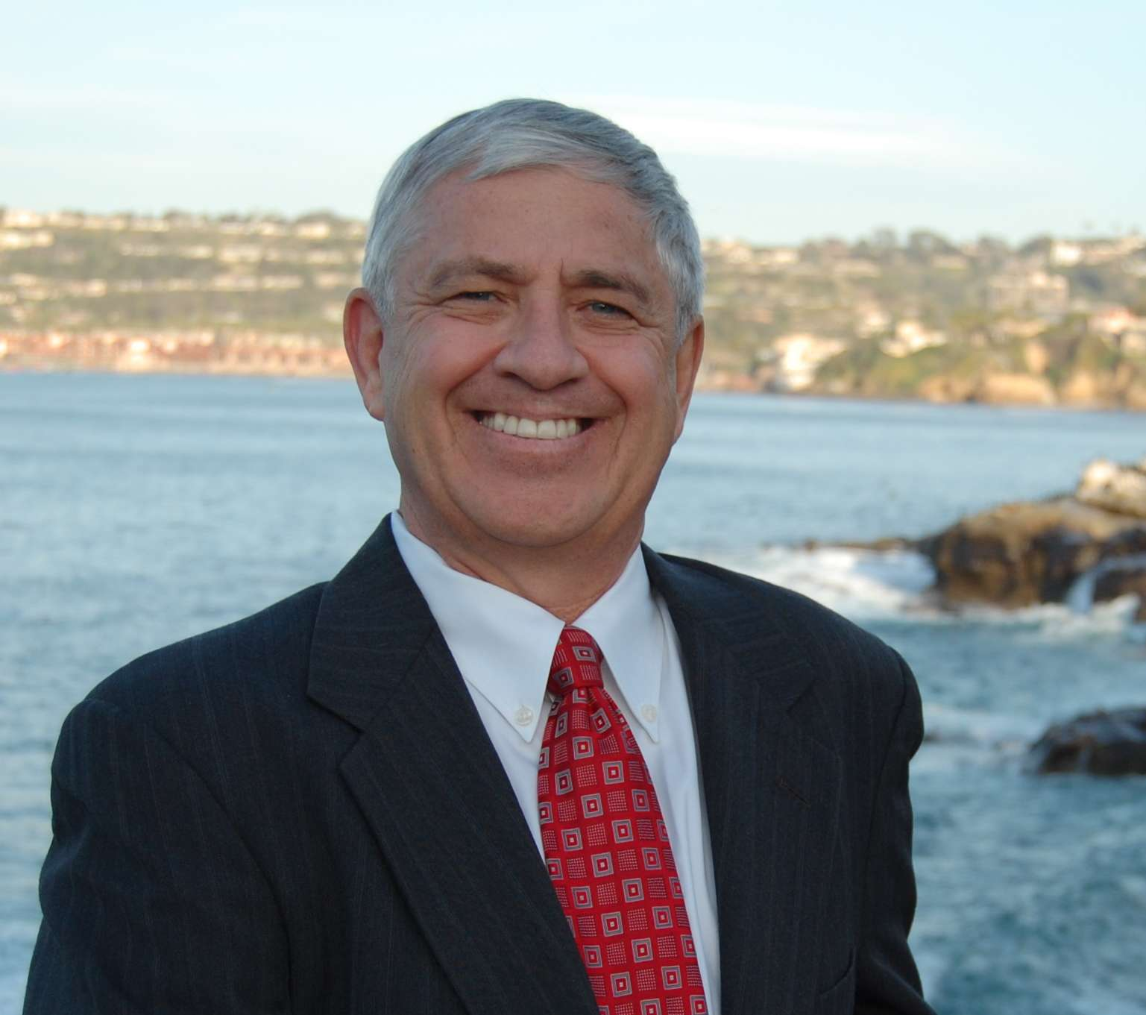
Michael J. Pallamary
Professional Land Surveyor
California License L4830
Date of Licensure: March 19, 1980

OFFICES

Pallamary & Associates
7755 Fay Avenue
Suite J
La Jolla, CA 92037
858-454-4094
www.pallamaryandassociates.com

President and Owner, Pallamary & Associates, La Jolla
President and Owner, Land Survey Service of La Jolla, 1983-Present
President and Owner, www.tiepoints.com
Executive Board Member Land Surveyors Advisory Council on Technical Standards
President and Owner, Precision Survey & Mapping (San Diego) 1983-1999
Associate Vice President and Director of Surveying and Mapping, P&D Consultants, Inc. (San Diego) 1999-2001

SPECIALIZED PROFESSIONAL COMPETENCE

Expert in the following: Land Surveying; land use; standard of care; boundary line determination and analysis; boundary disputes; deed interpretation; boundary reconstruction; easement analysis and construction; field engineering; map preparation; accident reconstruction studies; ALTA surveys; construction defects (survey related); photogrammetry; settlement/displacement surveys; view easements; historical property analysis; condominium plans, project permitting and processing, land planning, project administration; forensic land planning analysis; forensic site studies.

BACKGROUND AND PROFESSIONAL HONORS

Approved as an instructor by the State Bar of California through the National Business Institute (NBI) and the Lorman Seminars Program to teach educational programs in real property for State of California MCLE credits.
Graduate Certificate Land Surveying Program, Mesa College
Land Surveying Technology, Wentworth University
Surveying Technology, Eastern Massachusetts Association of Professional Engineers and Land Surveyors (EMAPELS)
Graduate of the Surveying Technology Program International Union of Operating Engineers
Apprentice Land Surveying Program, State of California Dept. of Industrial Relations
Co-Author City of San Diego Mapping & Land Title Document Preparation Manual
Self-Certified by the City of San Diego Development Services for Preparation and Processing of Tentative Maps and Map Waivers for Condominium Conversions and Creation of subdivision maps
American Society of Civil Engineers, Certificate of Appreciation
BACKGROUND AND PROFESSIONAL HONORS - CONTINUED

International Right of Way Association, Certificate of Appreciation
Research Engineers, Certificate of Training, Civil Engineering using Pacsoft Computer software
Certificate of Completion California Land Surveyors Subdivision Map Seminar
CE The Development Approval Process, Lorman
CE Eminent Domain Seminar, Lorman
CE Legal Descriptions and Survey Boundary Control, Wattles
CE Legal Aspects Seminar, Madson
CE Land Surveyors Legal Seminar
Member, American Planning Association (California Chapter)
Advisory Board Member, Pacific Land Foundation
Former Member, City of San Diego Board of Planning and Zoning Appeals by appointment of the Mayor and City Council of San Diego
Chairman, Mission Bay Capital Outlay Oversight Committee, by appointment of City Manager of San Diego
Former Elected Member, North Bay Revitalization Committee
Former Member, Mission Bay Park Planners
Former Member, Mission Bay Park Committee
Former Director, Morena Blvd. Business Improvement District
Past Chairman, Clairemont Mesa Planning Committee
Former Member, Surveyors Historical Society
Former Member, California Land Surveyors Association Legislative Review
Committee
Past Director, California Land Surveyors Association
Past-President, San Diego Chapter California Land Surveyors
Association
Past-Director, Engineers Club of San Diego
Past-Chairman, National Surveyors Week, California Land Surveyors
Association
Recipient, Vice-President’s Award, California Land Surveyors Association, San
Diego Chapter
Recipient, Spirit of Courage Award
Principle Author on behalf of Amicus Curiae (California Land Surveyors Association) in San Dieguito Partnership, L. P. v. City of San Diego, 7 Cal. App 4th 748
Former Executive Director, San Diegans for Sensible Land Use (SDSLU)
Recipient, Certificate of Appreciation, National Association of Women in the Construction Industry (Palomar Chapter).

SELECTED PUBLICATIONS

Staff Writer for The American Surveyor magazine (two monthly columns), “The Curt Brown Chronicles” and “Angle Points.” 2012 through present.
“The Curt Brown Chronicles – The Writings and Lectures of Curtis M. Brown,” History of Land Surveying in San Diego County,” Authorhouse Books Publications, 702 pp., (March, 2011)
“The Unforgiving Boundary – A Surveyor reflects on his experiences over nearly 30 years of surveying along the U.S.-Mexican border.” POB - Point of Beginning, (December, 2010)
“Phased Contracting – A New Model.” The American Surveyor, (Vol. 7 No. 4 - Spring 2010)
“Good contracts make for Good Clients.” POB – Point of Beginning, (June 2010)

SELECTED PUBLICATIONS - CONTINUED

“Conspiring for Land – How two neighbors’ boundary feud resulted in a murder for hire plot.” POB - Point of Beginning, (October, 2005)
“California Boundary Law,” National Business Institute Seminar Publication, (2005).
“Lay of The Land – The History of Land Surveying in San Diego County,” Authorhouse Books Publications, 384 pp., (November, 2003)
"A Brief History of Land Surveying,” The California Surveyor Magazine, (Spring, 2000).
"Where do we go from here? - A look at surveying in the new millennium," POB - Point of Beginning, (January, 2000)
“Personnel Practices – A look at Hiring, Employment and Termination in Today’s Workplace,” POB – Point of Beginning, (May, 1998)
“A Question of Ethics,” Professional Surveyor, (January, 1998)
“Benchmarks, Blufftops, and Boundary Lines: Locating and determining the Limits of Coastal Development,” The Pacific Land Foundation Journal, Fall (November, 1997).
“Boundary Law in California,” National Business Institute Seminar Publication, (1997).
“Boundary Law in California,” National Business Institute Seminar Publication, (1996).
“California Survey Issues: Recognition and Remediation,” National Business Institute Seminar Publication, (1995).
“Boundary Law in California,” National Business Institute Seminar Publication, (1994).
"Advanced Land Descriptions," Landmark Publications, co-authored with Roy Minnick and Paul Cuomo, (1993).
"Whose View is it Anyway," (A discussion on private view easements), The California Surveyor Magazine, Spring-Summer editions, (1993).
"Lot Line Adjustments Defined by Recent Court Case," The California Surveyor Magazine, (1992).
"The History of San Diego Land Surveying Experiences," Vanity Press, co-authored with Curtis M. Brown, (1988).
"Locating the New Madrid Fault Line," Professional Surveyor Magazine, (1990).
"Surveying the San Francisco Earthquake," Professional Surveyor Magazine, (Feature Story - 1990).
"Earthquakes: Picking Up The Pieces," Professional Surveyor Magazine, (1989).
"Joint Conference Report," The California Surveyor Magazine, (1987).
"City of San Diego Challenges State Board of Registration," The California Surveyor Magazine, (1987).
"CLSA Legal Seminar," The California Surveyor Magazine, (1986).
"Chapter Report," The California Surveyor Magazine, (1986).
"1986 CLSA Conference," The California Surveyor Magazine, (1986).
"Our Western Heritage," The California Surveyor Magazine, (1985).
"State Conference," The California Surveyor Magazine, (1985).

INVITED LECTURES

Invited Lecture before the San Diego Chapter of the California Land Surveyors Association, “Measurement Is Dead,” February, 2015.
Invited Lecture before the Professional Land Surveyors of Oregon’s Annual Conference, Salem, Oregon, “Curtis Brown Chronicles,” “Ethics and Standard of Care,” “Running a Successful Surveying Business,” “Reversionary Rights,” January, 2015.
INVITED LECTURES – CONTINUED

Invited Lecture before the Indiana Society of Professional Land Surveyors’ Annual Conference, Indianapolis, IN, “The Curt Brown Chronicles,” “Quality Control in Land Surveying,” January, 2015.
Invited Lecture before the Santa Clara/San Mateo Chapter of the California Land Surveyors Association, Ventura, CA, “Legal Aspects of Boundary Line Determination & Related Elements,” November, 2014.
Invited lecture before the Cal Poly Pomona University and Orange County Chapter of CLSA Joint Conference, Pomona, CA, “The Land Surveyor’s Professional Obligations - The Future of the Field Surveyor,” September, 2014.
Invited Lecture before the California County Recorder’s Association of California’s Annual Conference, San Diego, CA, “The Great Calamity: Missing Maps and the Plight of the Recorder,” September, 2014.
Invited Lecture before the California Cadastral Mapping Association Annual Conference, San Diego, CA, “Mapping Mysteries of the Wild West,” October 2013.
Invited Lecture on behalf of the Land Surveyors Advisory Council on Technical Standards (LSACTS), San Diego, CA, “Lot Line Adjustments or Boundary Line Agreements? What is the Correct Solution,” February, 2013.
Invited Lecture before the California Department of Transportation Caltrans Survey Academy II, Sacramento, CA, “Quality Control in Land Surveying,” January, 2013. (Note: Mr. Pallamary was the only private sector surveyor invited to speak and attend this program.)
Invited Lecture before the California Department of Transportation Caltrans Survey Academy II, Sacramento, CA, “Quality Control in Land Surveying,” January, 2012. (Note: Mr. Pallamary was the only private sector surveyor invited to speak and attend this program.)
Invited Lecture before the 51st Annual Surveying Engineering Conference at California State University, Fresno, CA. as a panel member, “The Curt Brown Chronicles,” January, 2012.
Invited Lecture as Faculty Member on behalf of the National Business Institute, Inc. Continuing Legal Education Program (Cal. State Bar), “Title Workshop: From Examination to Policy to Post-Policy,” January 2012.
Invited Lecture before The Channel Islands Chapter of the California Land Surveyors Association, Ventura, CA, “The Curt Brown Chronicles,” October, 2011
Invited Lecture before The Massachusetts Association of Land Surveyors and Civil Engineers (MALSCE) Annual Conference, Hyannis, MA, “The Curt Brown Chronicles,” October, 2011
Invited Lecture before The Riverside Chapter of the California Land Surveyors Association, Ventura, CA, “The Curt Brown Chronicles,” August, 2011
Invited Lecture before The San Diego Chapter of the California Land Surveyors Association, Ventura, CA, “The Curt Brown Chronicles,” August, 2011
Invited Lecture before The League of California Surveying Organizations, Riverside CA, “Eminent Domain & The Private Sector Land Surveyor – The Other Side of The Table,” April, 2011.
Invited Lecture before the 50th Annual Surveying Engineering Conference at California State University, Fresno, CA, “How to Run a More Successful Land Surveying Business,” January, 2011.
Invited Lecture before the 50th Annual Surveying Engineering Conference at California State University, Fresno, CA. as a panel member, “Continuing Education and Educational Requirements in Land Surveying,” January, 2011.
Invited Lecture before the San Diego Chapter of the California Land Surveyors Association, “Local Datum Issues – Does Anyone Know Where Sea Level Is?” September, 2010.
INVITED LECTURES – CONTINUED

Invited Lecture before the California Department of Transportation Caltrans Survey Academy II, Sacramento, CA, “Quality Control in Land Surveying,” March, 2010. (Note: Mr. Pallamary was the only private sector surveyor invited to speak and attend this program.)
Invited Lecture before the 49th Annual Surveying Engineering Conference at California State University, Fresno, CA, “Reversionary Rights,” January, 2010.
Invited Lecture before the 49th Annual Surveying Engineering Conference at California State University, Fresno, CA, “Applying the Rules of Land Surveying to Traffic Ticket Laws,” January, 2010.
Invited Lecture before the California Land Surveyors Association 2009 State Conference, Land Surveyors License Review Examination, San Diego, CA, “Boundary Determination,” April 2009.
Invited Lecture before the San Diego Chapter of the California Land Surveyors Association, Land Surveyors License Review Examination, “Boundary Determination,” March 2009.
Keynote Speaker before the 48th Annual Surveying Engineering Conference at California State University, Fresno, CA, “Utilizing Modern Technology in the Land Surveying Profession – A Historical Overview,” January, 2009.
Invited Lecture before the 48th Annual Surveying Engineering Conference at California State University, Fresno, CA, “Land Surveyor Liability,” January, 2009.
Invited Lecture before the Bakersfield Chapter of the California Land Surveyors Association, “Reversionary Rights,” October 2008.
Invited Lecture before the Marin Chapter of the California Land Surveyors Association, “Managing Liability in a Professional Land Surveying Practice,” May 2008.
Invited Lecture before the 47th Annual Surveying Engineering Conference at California State University, Fresno, CA, “Opening and Maintaining a Surveying Business,” January, 2008.
Invited Lecture before the 47th Annual Surveying Engineering Conference at California State University, Fresno, CA, “Implementing Quality Control & Quality Assurance Methods,” January, 2008.
Invited Lecture before the San Diego Chapter of the California Land Surveyors Association, “Reversionary Rights,” November 2007.
Invited Lecture before the Santa Clara/San Mateo Chapter of the California Land Surveyors Association, “Preparation and Processing of Condominium Plans & Mapping,” November 2007.
Invited Lecture as Faculty Member of Lorman Education Services delivered in Santa Ana, California, “Legal Aspects of Condominiums and Homeowners’ Association in California,” August 2007.
Invited Lecture as Faculty Member of the Pacific Land Foundation delivered in La Mirada, California, “Lot Line Adjustments - Lot Line Agreements – Lot Mergers and Certificates of Compliance – Can it get any more confusing”? November 2006.
Invited Lecture as Faculty Member of the Pacific Land Foundation delivered in Concord, California, “Lot Line Adjustments - Lot Line Agreements – Lot Mergers and Certificates of Compliance – Can it get any more confusing”? November 2006.
Invited Lecture as Faculty Member of Lorman Education Services delivered in Santa Ana, California, “Establishing and Operating Homeowners’ Associations: Understanding the Legal Issues in California,” August 2006.
Invited Lecture before the Southern California Section of the American Congress on Surveying and Mapping (ACSM), “Lot Line Adjustments, Lot Line Agreements, Lot Mergers and Certificates of Compliance – Can it get any more confusing?” August, 2006.
Invited Lecture before the Marin Chapter of the California Land Surveyors Association, “Ethics and Standard of Care” and “View Easements,” May 2006.
Invited Lecture as Faculty Member of the Pacific Land Foundation delivered in Concord, California, “Planning and Preparation of Condominium Plans,” September 2005.
INVITED LECTURES – CONTINUED

Invited Lecture as Faculty Member of the Pacific Land Foundation delivered in Fresno, California, “Planning and Preparation of Condominium Plans,” July 2005.
Invited Lecture as Faculty Member of the Pacific Land Foundation delivered in Thousand Oaks, California, “Planning and Preparation of Condominium Plans,” June 2005.
Invited Lecture as Faculty Member of the Pacific Land Foundation delivered in Ontario, California, “Planning and Preparation of Condominium Plans,” June 2005.
Invited Lecture as Faculty Member of the Pacific Land Foundation delivered in San Diego, California, “Planning and Preparation of Condominium Plans,” June 2005.
Invited Lecture before the 2005 ACSM-CLSA-NALS-WFPS Conference and Technology Exhibition in Las Vegas, Nevada, “Historic Surveyors of Southern California,” March, 2005.
Invited Lecture as Faculty Member of the Pacific Land Foundation delivered in San Diego, California, “Planning and Preparation of Condominium Plans,” March 2005.
Invited Lecture before the 43rd Annual Surveying Engineering Conference at California State University, Fresno, “Survey Monuments and Corners,” January, 2005.
Invited Lecture as Faculty Member of the Pacific Land Foundation delivered in Stockton, California, “Planning and Preparation of Condominium Plans,” January 2005.
Invited Lecture as Faculty Member on behalf of the National Business Institute, Inc. Continuing Legal Education Program (Cal. State Bar); “California Boundary Law: Critical Issues and Solutions Every Practitioner Should Know,” January 2005.
Invited Lecture as Faculty Member on behalf of the National Business Institute, Inc. Continuing Legal Education Program (Cal. State Bar); “Boundary Law in California,” June 1993, April 1994, April 1996, September 1997, May 2003 and “California Survey Issues - Recognition and Remediation,” March 1995.
Invited Lecture on behalf of the Pacific Land Foundation delivered in Portland, Oregon, “Ethics and Standard of Care,” April 2001.
Invited Lecture before the San Diego Chapter of the California Land Surveyors Association, “Land Surveyor Review Class - Boundary Surveys,” February 2001.
Invited Lecture before The Los Angeles Chapter of the California Land Surveyors Association, “Standard of Care and Ethics,” July 2000.
Invited Lecture before The League of California Surveying Organizations (Southern Region), “Standard of Care,” April 2000.
Invited Lecture before the San Diego Chapter of the California Land Surveyors Association, “Land Surveyor Review Class - Boundary Surveys,” April 2000.
Invited Lecture before the Twelfth Annual Pomona State Polytechnic University Surveying and Mapping Conference, “Legal Issues for the Land Surveyor - A New Millennium,” November, 1999.
Invited lecture before the Orange County Chapter of the California Land Surveyors
Association, "Current Boundary Disputes: Case Studies," April 1999.
Invited Lecture before the San Diego Chapter of the California Land Surveyors Association, “Land Surveyor Review Class - Legal Descriptions,” April 1999.
Invited Lecture before the Riverside/San Bernardino Chapter of the California Land Surveyors Association, “Land Surveyor Review Class - Legal Descriptions,” February 1999.
Invited Lecture before the San Diego Chapter of the California Land Surveyors Association, “Land Surveyor Review Class - Boundary Surveys,” April 1998.
Invited Seminar Speaker for the Southern California Section of the American Congress of Surveying and Mapping and the Orange County and Los Angeles Chapters of the California Land Surveyors Association, “A. L. T. A. Survey Update and The LS Act – Current Issues,” February 1998.
Invited Guest on the “Real Estate Today” Radio Show, hosted by Robert Griswold on News Radio KOGO 600, San Diego, December, 1997
INVITED LECTURES – CONTINUED

Invited Seminar Speaker for the Pacific Land Foundation, “The Quasi-Judicial
Functions of the Land Surveyor,” February, 1997.
Invited Lecture before the 36th Annual Surveying Engineering Conference at California State University, Fresno, “Mapping Mysteries of Mission Beach,” January, 1997.
Invited Lecture before the San Diego County Chapter of the California Land Surveyors Association, “Meandering the Mysteries,” August, 1997.
Invited Lectures before the San Diego Chapter of the California Land Surveyors Association Continuing Education Program; “The Role of the Land Surveyor as an Expert Witness,” October, 1997; "Troublesome Legal Descriptions," November, 1996; "Private View Easements," November, 1993; "Regional Mapping Mysteries" and "Boundary Line Agreement Panel Discussion," October, 1992.
Invited Lecture before the Ninth Annual Pomona State Polytechnic University Surveying and Mapping Conference, “A Question of Ethics,” October 1996.
Invited Lecture before the Orange County Chapter of the California Land Surveyors Association, “View Easements,” April 1996.
Invited Lecture as Continuing Guest Faculty Member at UCSD, “Continuing Education in Real Estate Practices” and “Real Estate Law in California”, 1995-1999.
Invited Lecture before the Riverside/San Bernardino Chapter of the California Land Surveyors Association, “Land Surveyor Review Class - Land Descriptions,” March 1996, March 1997, February 1998.
Invited Lecture before the Seventh Annual Pomona State Polytechnic University Surveying and Mapping Conference, “Mapping Mysteries of La Jolla and Mission Beach,” October 1994.
Invited Pre-Conference Lecture before the Sixth Annual Pomona State Polytechnic
University Surveying and Mapping Conference, "Three-Dimensional Property Descriptions," October 1993.
Invited Lecture before the California Land Surveyors Association Annual Conference;
"Defining and Describing Three Dimensional Property Descriptions," March, 1993.
Invited Lecture before the Eleventh Annual Cadastral Survey Meeting of the United States Forest Service and the Bureau of Land Management; "Earthquakes and Land Surveying," January, 1993.
Invited Lecture before the Fifth Annual Pomona State Polytechnic University Surveying and Mapping Conference, "Boundary Line Agreements versus Boundary Line Adjustments; What's the Difference and Who Cares?" September, 1992.
Invited Lecture before the Third Annual Pomona State Polytechnic University Surveying and Mapping Conference, "Post - Earthquake Surveying," September, 1990.
Invited Lecture before The Illinois Registered Land Surveyors Association Annual Conference, "Surveying After an Earthquake," March, 1990.
Invited Lecture before the California Land Surveyors Association Annual Conference, "Historical Surveys of San Diego," March, 1989.
Invited Lecture before the California Land Surveyors Association and Nevada Land Surveyors Association Joint Conference, "Mapping Mysteries of Coronado", March, 1988.
Invited Lecture before the California Land Surveyors Association and Nevada Land Surveyors Association Joint Conference, "Historical Surveys of San Diego County," April, 1990.
Seminar Speaker before the California Association of Subdivision Consultants, "Toxic Building Sites: To Build or not to Build," August, 1989.
Invited Lecture before the California Association of Subdivision Consultants, "Title Mysteries of Coronado," September, 1987
INVITED LECTURES – CONTINUED

Invited Seminar Speaker with Curtis M. Brown, LS before the California Land Surveyors Association, "Historical Surveys of San Diego County," June, 1987

resume/mpallamaryresume 031915

